WEEK 3 – Advanced Data Analysis and Visualization
The cleaned dataset was analyzed to understand delivery reliability, cost patterns, carrier performance, transport-mode differences and weekly operational trends.

3.1 Carrier Performance
Carrier | Shipments | Avg_Delivery_Days | On_Time_Rate | Avg_Cost_INR
Bluedart | 1742 | 3.75 | 62.86 | 11344.29
Fedex | 1558 | 3.71 | 61.75 | 11524.09
Dhl | 3726 | 3.81 | 60.31 | 11705.46
Delhivery | 3261 | 3.78 | 60.29 | 11681.29
Ecom Express | 1713 | 3.80 | 60.19 | 11772.20

3.2 Transport Mode Performance
Transport_Mode | Shipments | Avg_Delivery_Days | On_Time_Rate | Avg_Cost_INR
Rail | 3995 | 3.76 | 62.25 | 11822.99
Road | 4002 | 3.79 | 60.29 | 11548.19
Air | 4003 | 3.79 | 59.98 | 11526.51

3.3 Weekly Performance
Order_Week | Shipments | Avg_Delivery_Days | On_Time_Rate | Avg_Shipping_Cost
1.00 | 453.00 | 3.78 | 56.73 | 12169.06
2.00 | 584.00 | 3.65 | 61.13 | 11610.72
5.00 | 155.00 | 3.36 | 64.52 | 12380.55
6.00 | 600.00 | 3.71 | 62.83 | 11829.88
7.00 | 238.00 | 3.61 | 60.50 | 11549.13
9.00 | 152.00 | 3.97 | 62.50 | 12130.34
10.00 | 600.00 | 3.83 | 57.67 | 11453.26
11.00 | 245.00 | 3.69 | 62.04 | 11494.49
14.00 | 554.00 | 3.65 | 64.44 | 11341.21
15.00 | 536.00 | 3.82 | 59.14 | 11811.71
18.00 | 234.00 | 4.00 | 61.54 | 11623.81
19.00 | 594.00 | 3.85 | 61.28 | 11318.82

3.4 Correlation Matrix
index | Distance_km | Shipment_Weight_kg | Quantity | Shipping_Cost_INR | Promised_Delivery_Days | Actual_Delivery_Days | Customer_Rating | Fuel_Surcharge_INR | Warehouse_Processing_Hours | Temperature_C
Distance_km | 1.00 | -0.01 | 0.01 | 0.83 | -0.00 | 0.00 | -0.00 | 0.78 | -0.00 | -0.00
Shipment_Weight_kg | -0.01 | 1.00 | -0.00 | 0.07 | -0.02 | -0.01 | 0.00 | -0.01 | 0.01 | -0.00
Quantity | 0.01 | -0.00 | 1.00 | -0.01 | -0.01 | -0.01 | 0.00 | 0.00 | -0.01 | 0.01
Shipping_Cost_INR | 0.83 | 0.07 | -0.01 | 1.00 | 0.00 | 0.02 | 0.00 | 0.66 | -0.01 | 0.00
Promised_Delivery_Days | -0.00 | -0.02 | -0.01 | 0.00 | 1.00 | 0.72 | -0.01 | -0.00 | 0.01 | -0.01
Actual_Delivery_Days | 0.00 | -0.01 | -0.01 | 0.02 | 0.72 | 1.00 | -0.02 | -0.00 | -0.00 | -0.00
Customer_Rating | -0.00 | 0.00 | 0.00 | 0.00 | -0.01 | -0.02 | 1.00 | -0.00 | -0.01 | 0.00
Fuel_Surcharge_INR | 0.78 | -0.01 | 0.00 | 0.66 | -0.00 | -0.00 | -0.00 | 1.00 | -0.00 | -0.00
Warehouse_Processing_Hours | -0.00 | 0.01 | -0.01 | -0.01 | 0.01 | -0.00 | -0.01 | -0.00 | 1.00 | 0.01
Temperature_C | -0.00 | -0.00 | 0.01 | 0.00 | -0.01 | -0.00 | 0.00 | -0.00 | 0.01 | 1.00
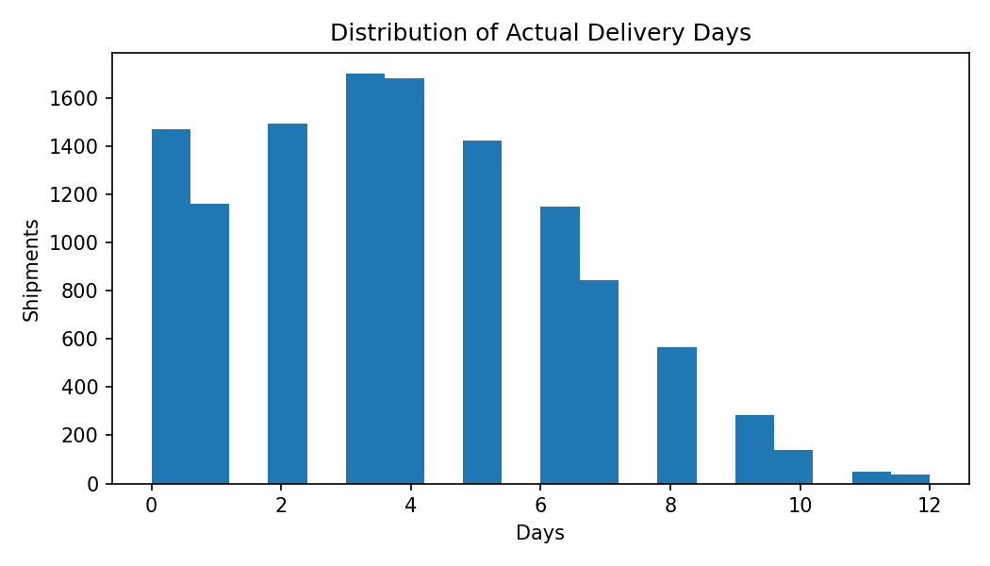
Distribution of Actual Delivery Days
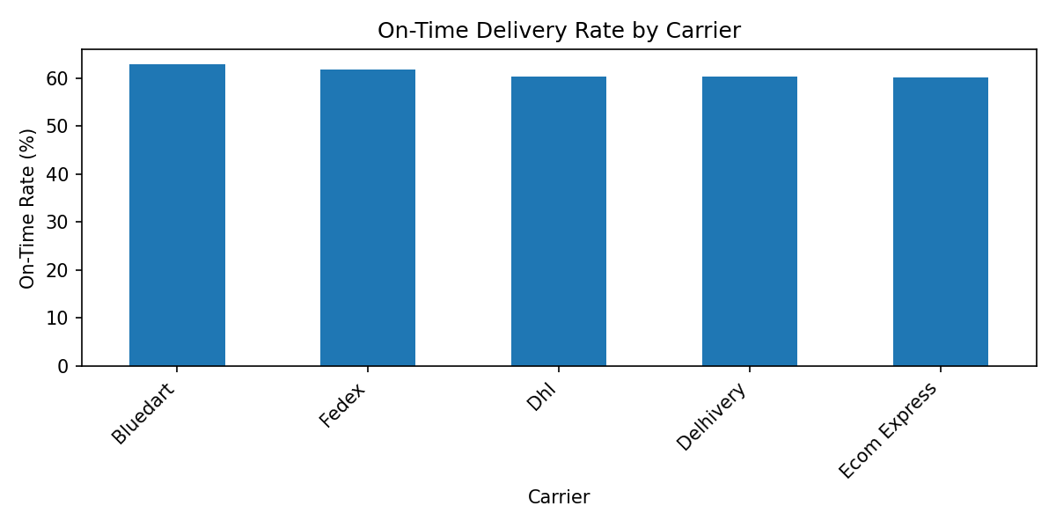
On-Time Delivery Rate by Carrier
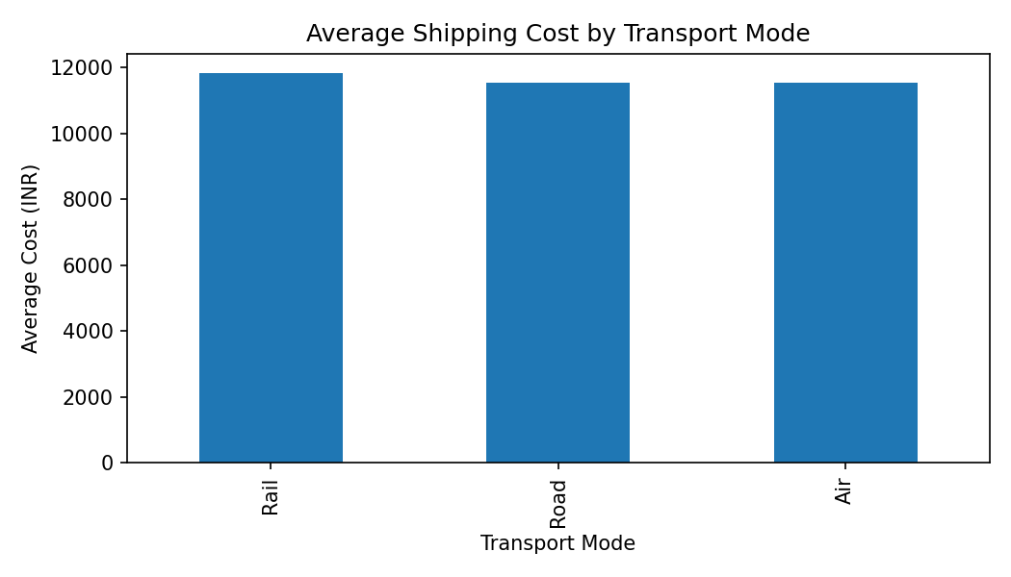
Average Shipping Cost by Transport Mode
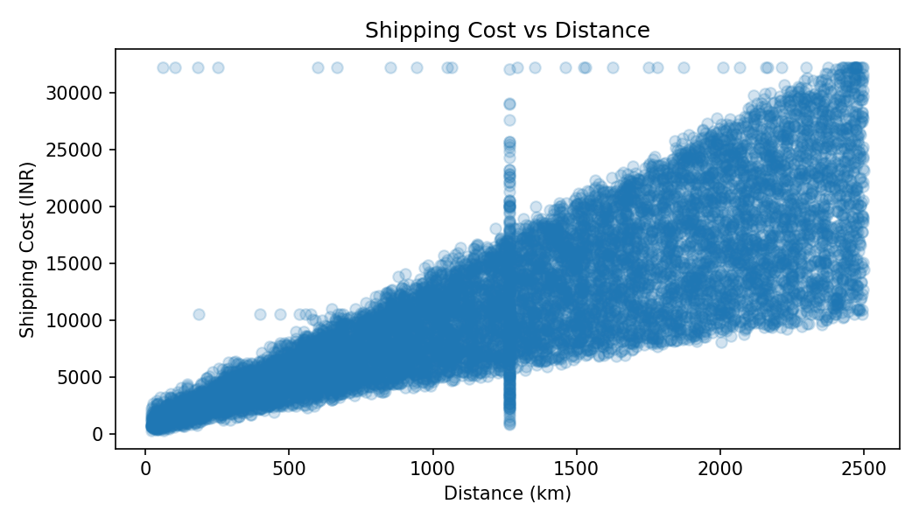
Shipping Cost vs Distance
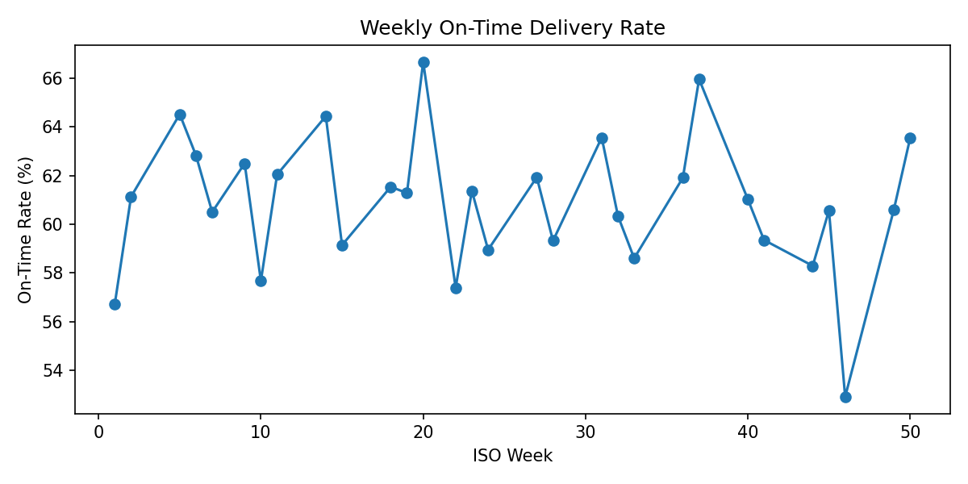
Weekly On-Time Delivery Rate

3.5 Findings
The prepared dataset has an overall on-time delivery rate of 60.84% and an average actual delivery time of 3.78 days. Carrier and transport-mode comparisons show that operational performance differs across categories, so allocation decisions should consider both reliability and cost rather than a single KPI. The weekly chart provides a simple monitoring mechanism for identifying changes in service performance over time. The cost-versus-distance chart can be used to investigate routes with unusually high expenditure. Correlation analysis provides a first diagnostic view of relationships among numerical variables, while recognizing that correlation does not establish causation.

